1: Personal Web page 09/10/2019

**Problem 1 : Personal Web page**

**AIM:**

1.Design a sample personal web page using three

separate pages such as

(i) Home page.

(ii) Educational Qualification

(iii) Contact me

**PROGRAM CODE:**



|  |  |
| --- | --- |
| Index.html | <html>  <head>  <title>Personal</title>  </head>  <body background="background.jpg">  <h1 align="center"><font color="red"><i>Andrew Someone</i></font>  <center><h6><a href="index.html">Home</a>  <a href="edu.html">Education</a>  <a href="contact.html">Contact</a>  </center>  <marquee><font color="red">!!Attention Check About!!</font></marquee>  </h3><h2> <u>About</u></h2></br><img src="profileimage.jpg" width="350" height="250">  <div><font size="5"><b>Just some basic things about me. I am Lorem Ipsum, a software engineer having 4 years of industrial experience.</br>  </br>  <i>Just another paragraph about me which simply talking about myself. And this is some dummy text</font>  </div>  </body>  </html> |
| edu.html | <html>  <body background="background.jpg">  <center>  <h1> EDUCATIONAL DETAILS</h1>  <table border="5" width="50%" height="50%">  <tr>  <th> <h4>Education</h4></th>  <th> <h4>Qualification</h4 ></th>  </tr>  <tr>  <td> B.Tech</td>  <td> 78.0 </td>  </tr>  <tr>  <td> Higher Secondary</td>  <td> 83.0 </td>  </tr>  <tr>  <td> Primary school graduation</td>  <td> 67.0 </td>  </tr>  </table></center>  </body>  </html> |
| Contact.html | <html>  <body background="https://cdn.pixabay.com/photo/2015/12/03/08/50/paper-1074131_960_720.jpg">  <center>  <h1> CONTACT</h1>  <div><br><h2>  Blaa Blaa<br>  Near foo foo<br>  Kerala<br>  Email: shashfsjfhs@ifhie.com</h2>  </div>  </center>  </body>  </html> |  |

Web Programming Lab 2

1: Personal Web page 09/10/2019

**RESULT**

Text here(font size 12, font type: Calibri)

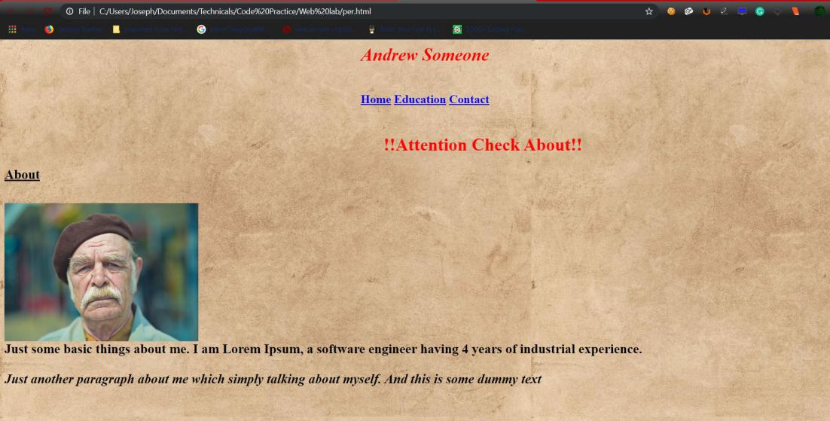

Figure 1: index.html

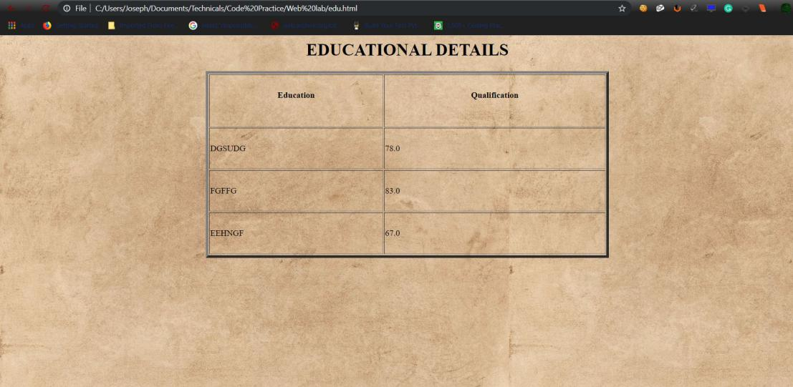

Figure 2: edu.html

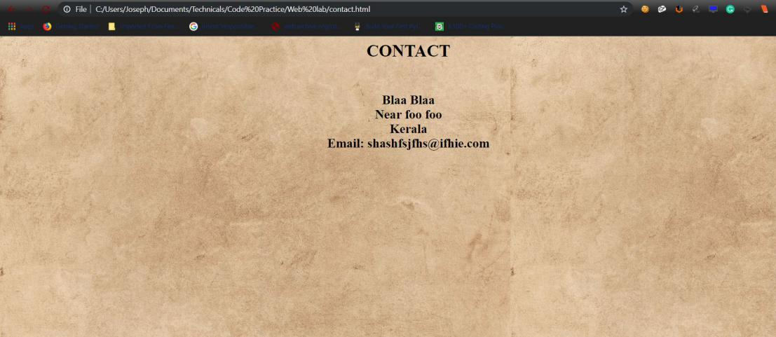

Figure 3: contact.html

Web Programming Lab 3